Deadlocks

A process requests resources; and if the resources are not available at that time, the process enters a waiting state.

Sometimes, a waiting process is never again able to change state, because the resources it has requested are held by other waiting processes.

Resource Types

Memory space CPU Cycles Files I/O Devices

Normal mode of operation:

1. Request
2. Use
3. Release

A deadlock situation can arise if the following four conditions hold simultaneously in a system:

1. Mutual exclusion (non-sharable mode)
2. Hold and wait
3. No preemption
4. Circular wait

Resource-Allocation Graph

Request Edge Assignment Edge

Example 1:

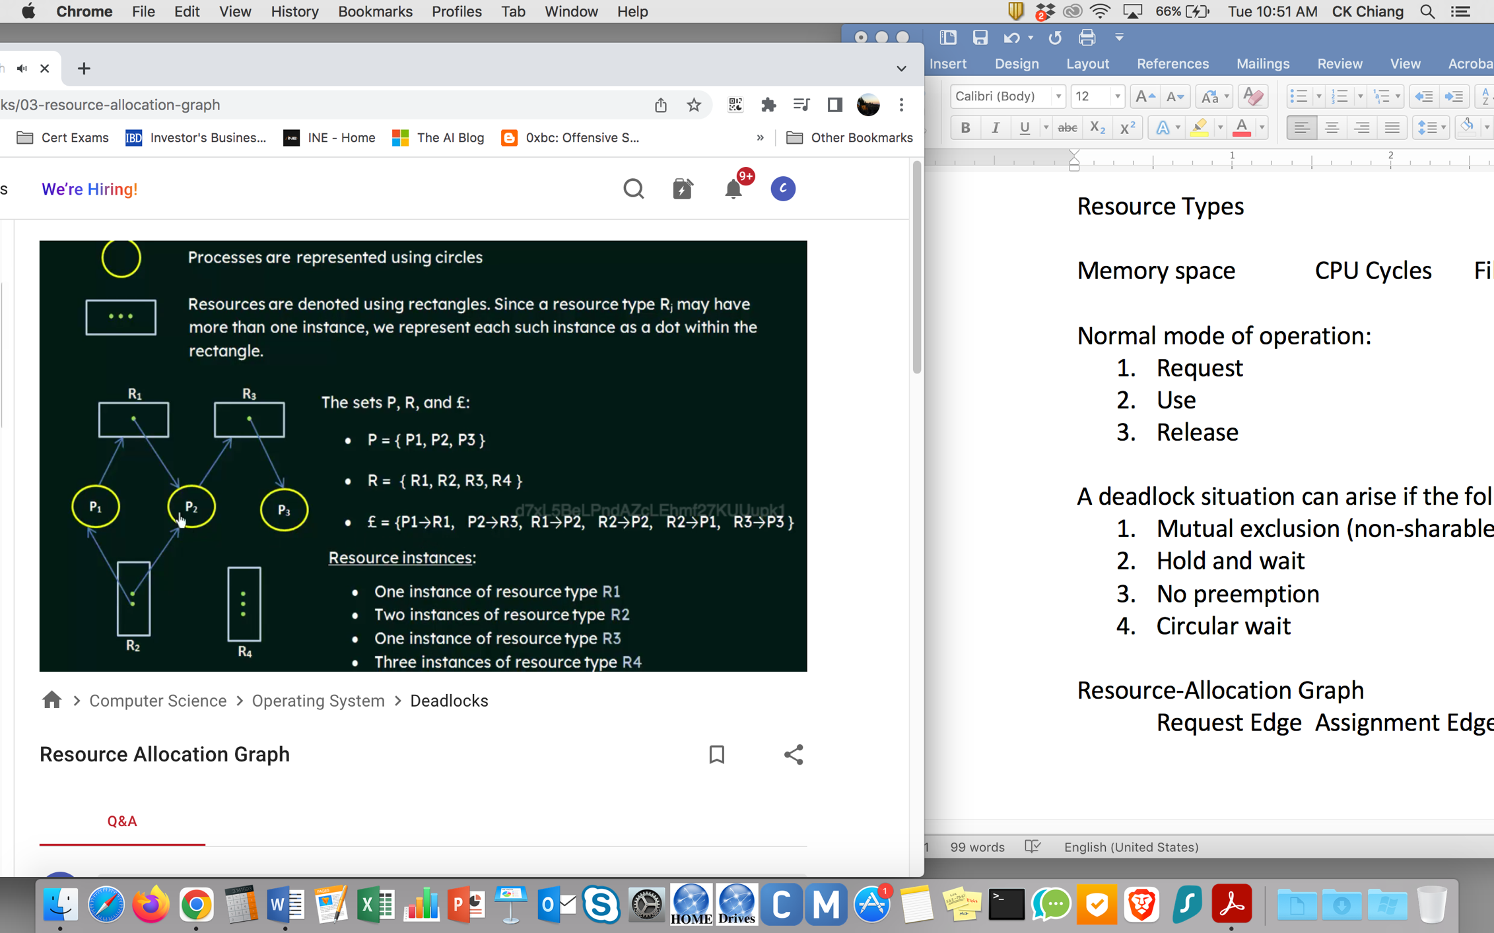

Example 2:

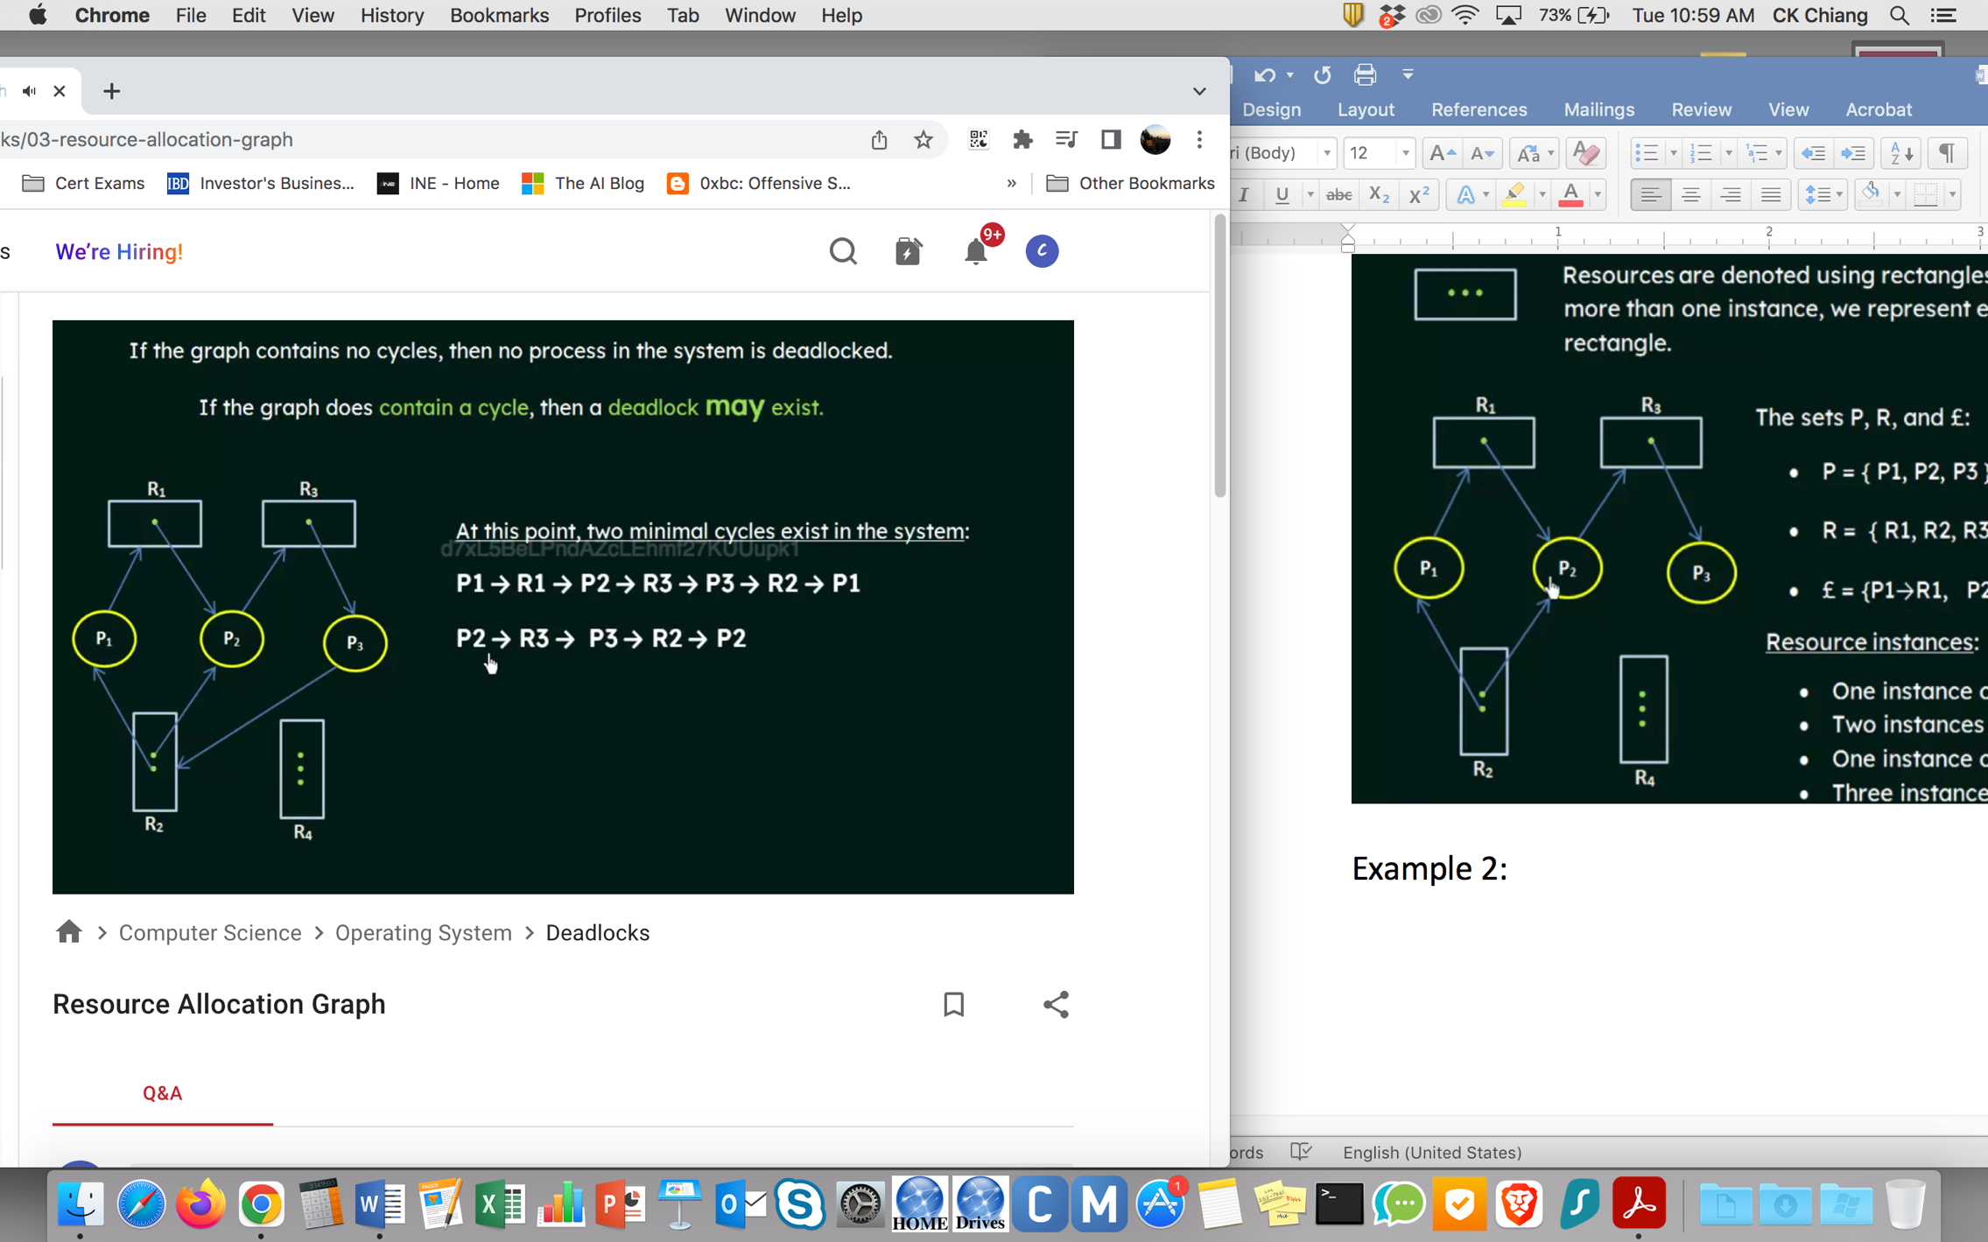

Example 3:

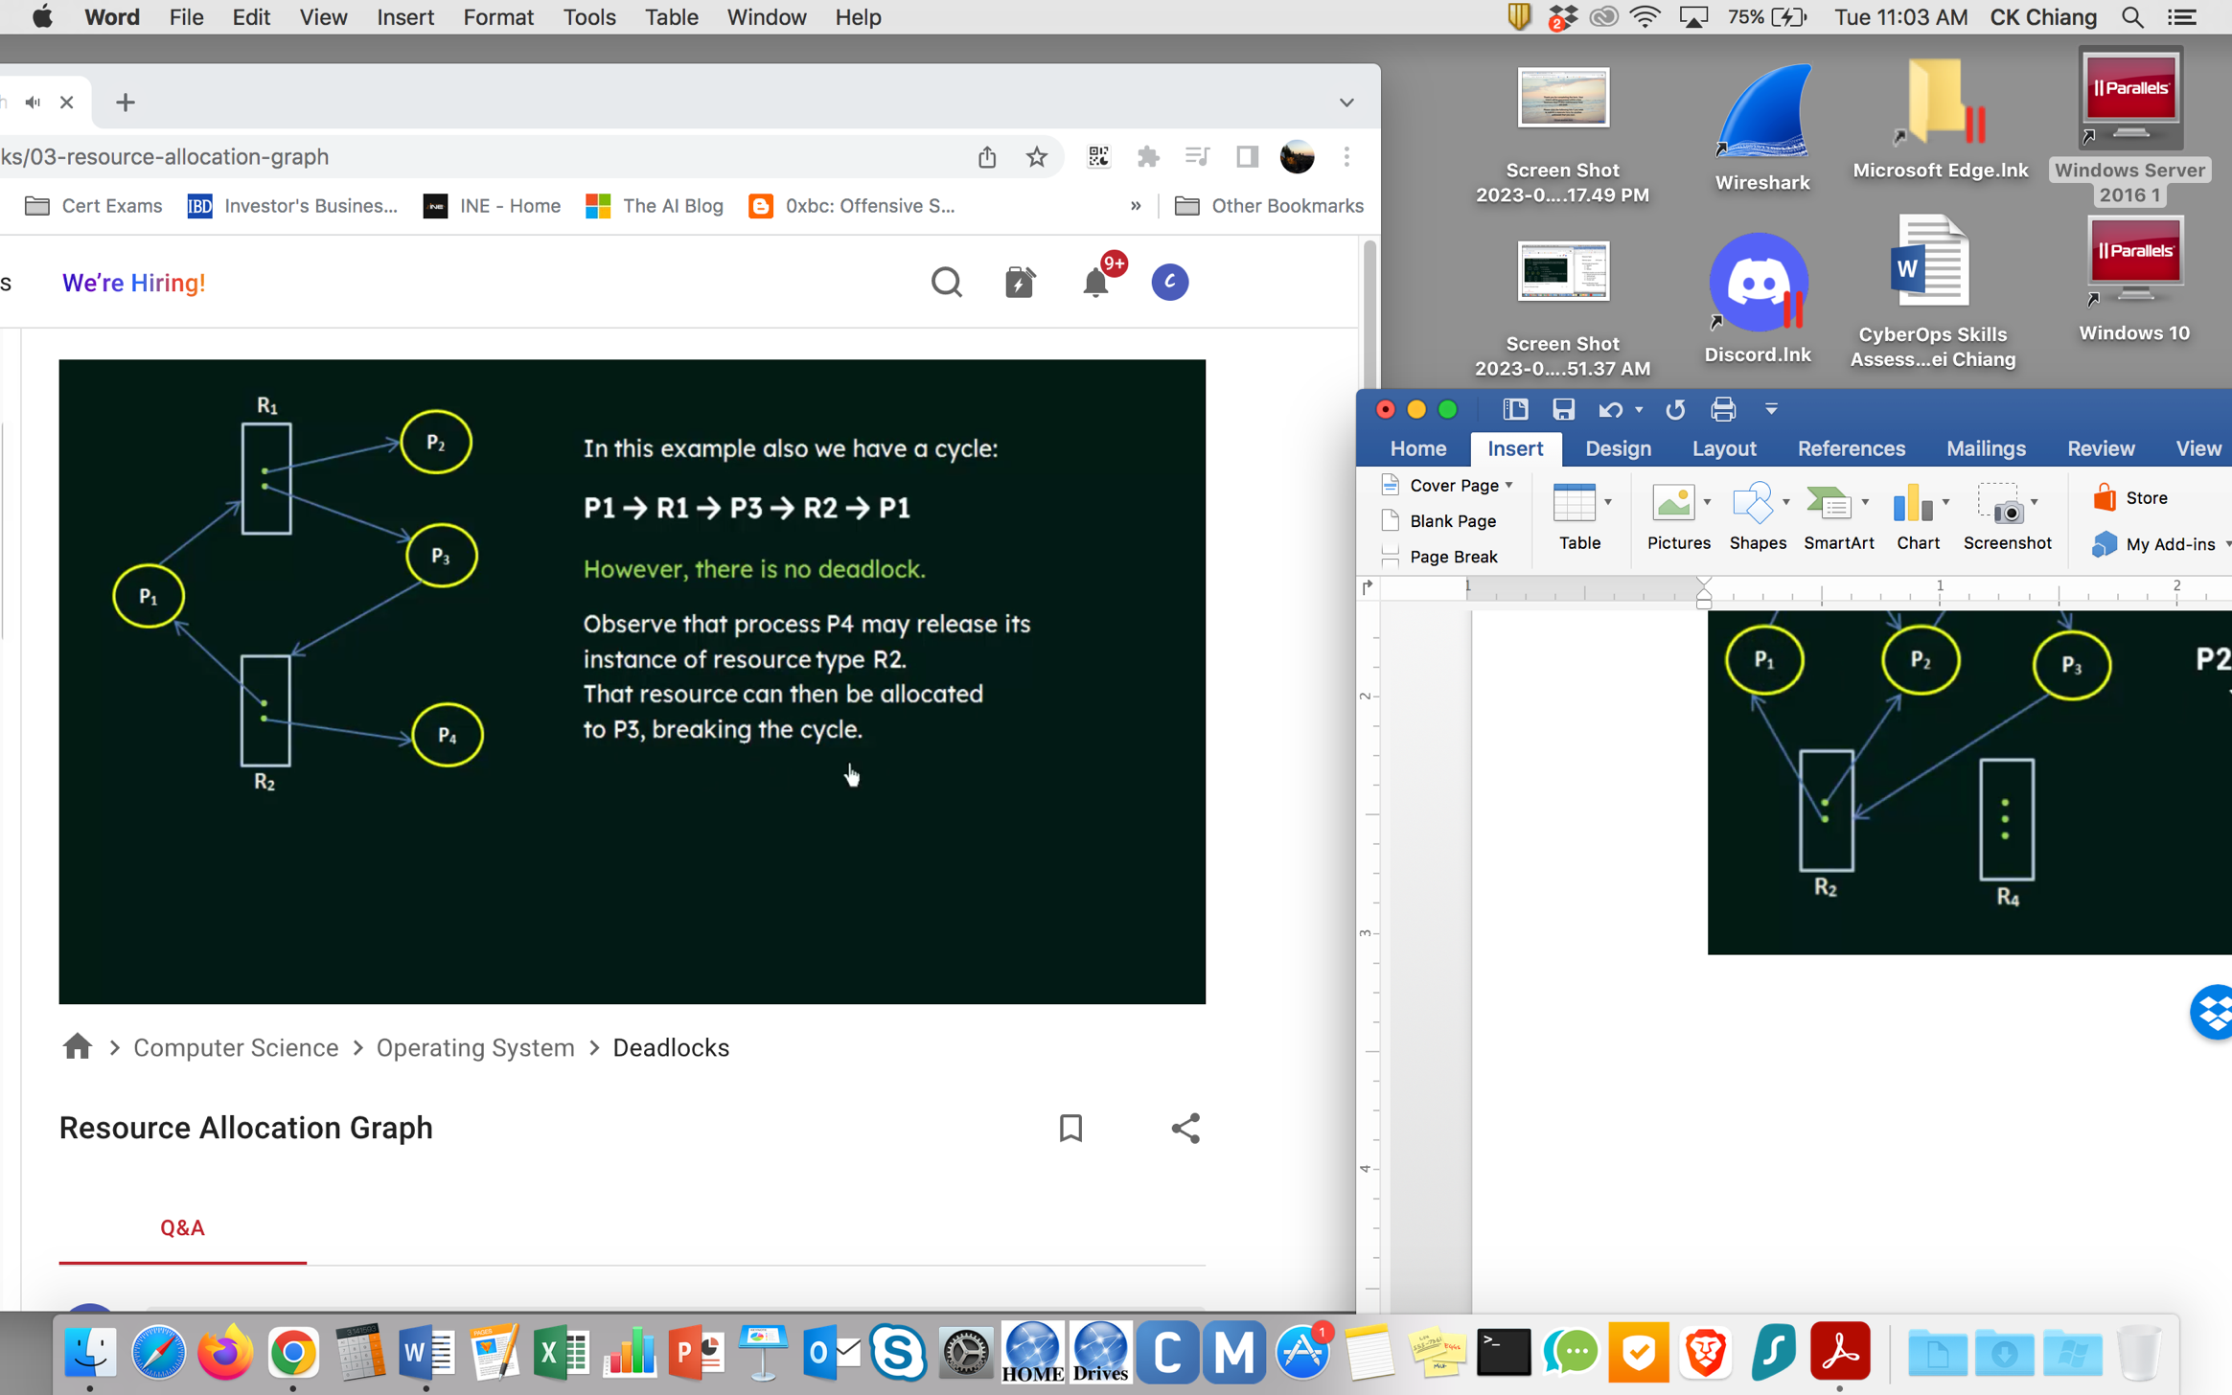

Methods for Handling Deadlocks

1. Prevention or avoidance
2. Allow, detect, and then resolve
3. Ignore

Deadlock Prevention

Mutual Exclusion

A printer cannot be simultaneously shared by several processes.

Read-only files

Hold and Wait

Whenever a process requests a resource, it does not hold any other resources.

Allocates all its resources before it begins execution.

It must release all the resources that it is currently allocated.

Disadvantages: 1. Resource utilization may be low

2. Starvation is possible

No Preemption

Circular wait

Deadlock Avoidance

Required additional information about how resources are to be requested.

Safe State – A state is safe if the system can allocate resources to each process (up to its max.) in some order and still avoid a deadlock.

Resource-Allocation-Graph Algorithm

Claim edge: P -> R means P may request resource at some time in the future.

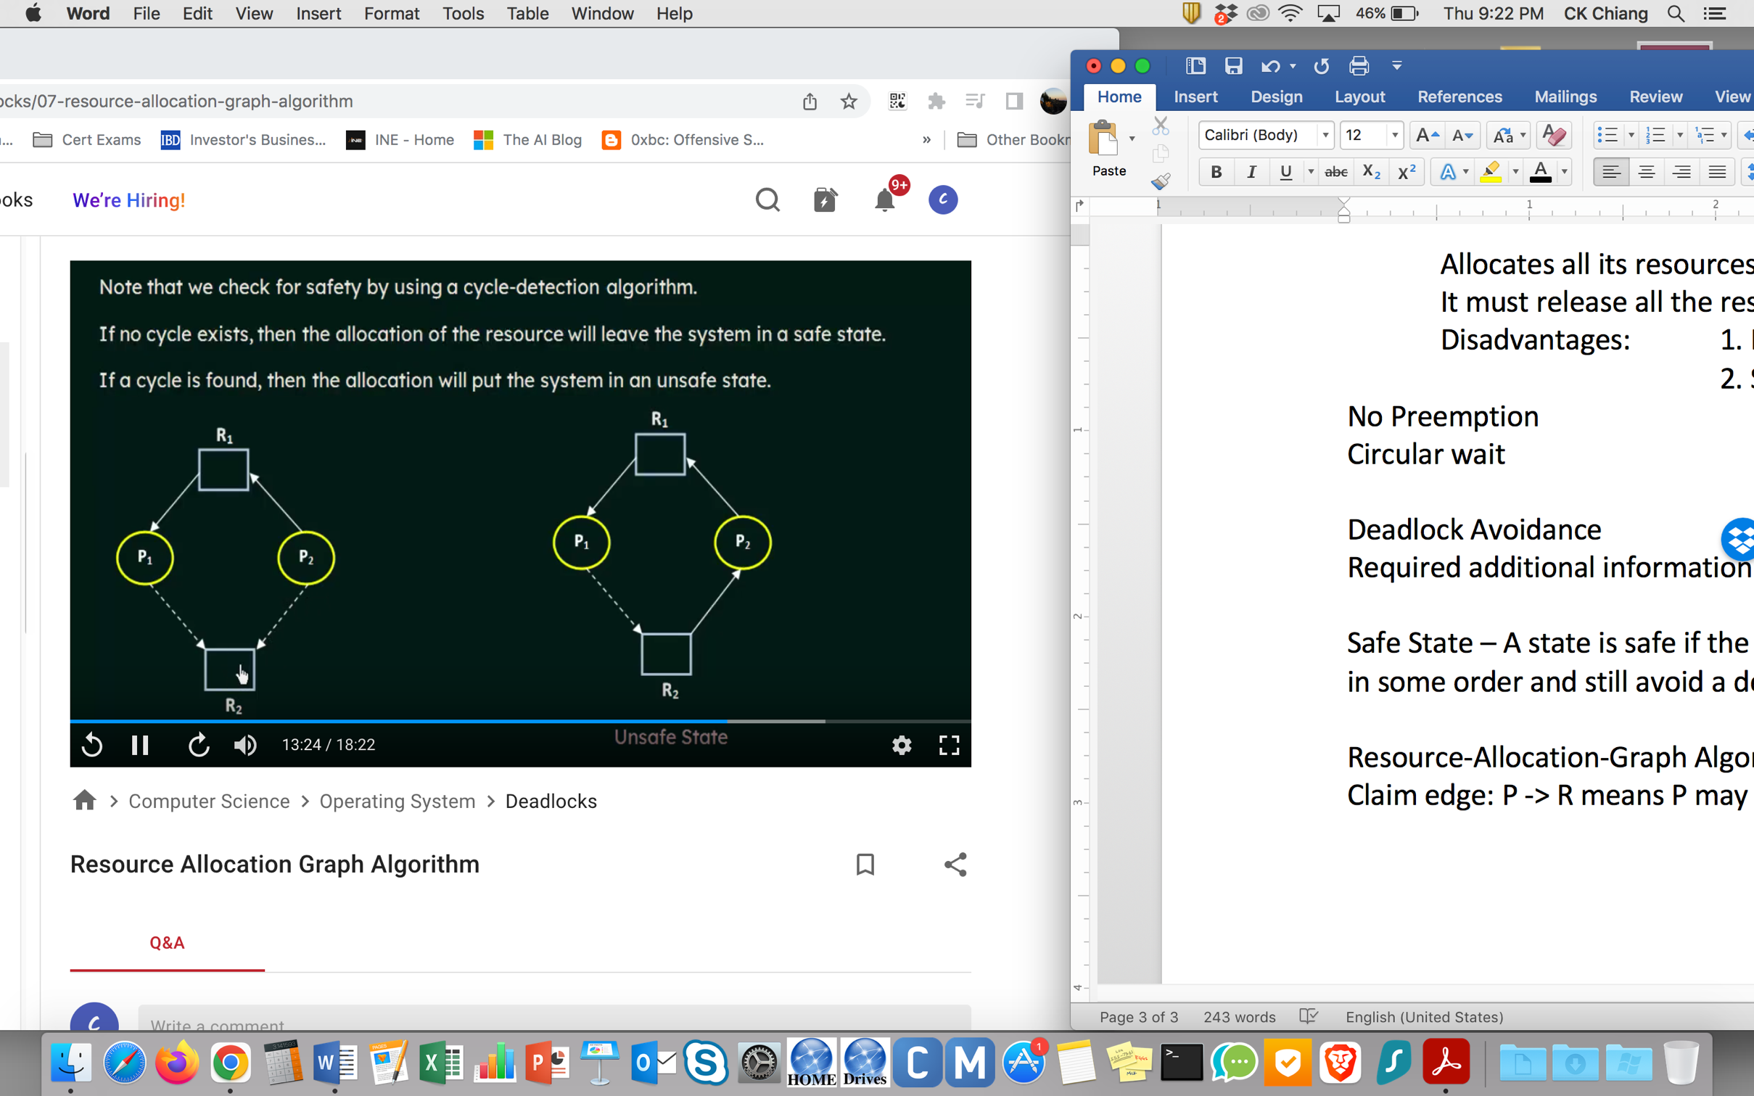

Deadlock Avoidance

Banker’s Algorithm (with multiple instances of each resource)

Need [I, j] = Max [I, j] – Allocate [I, j]

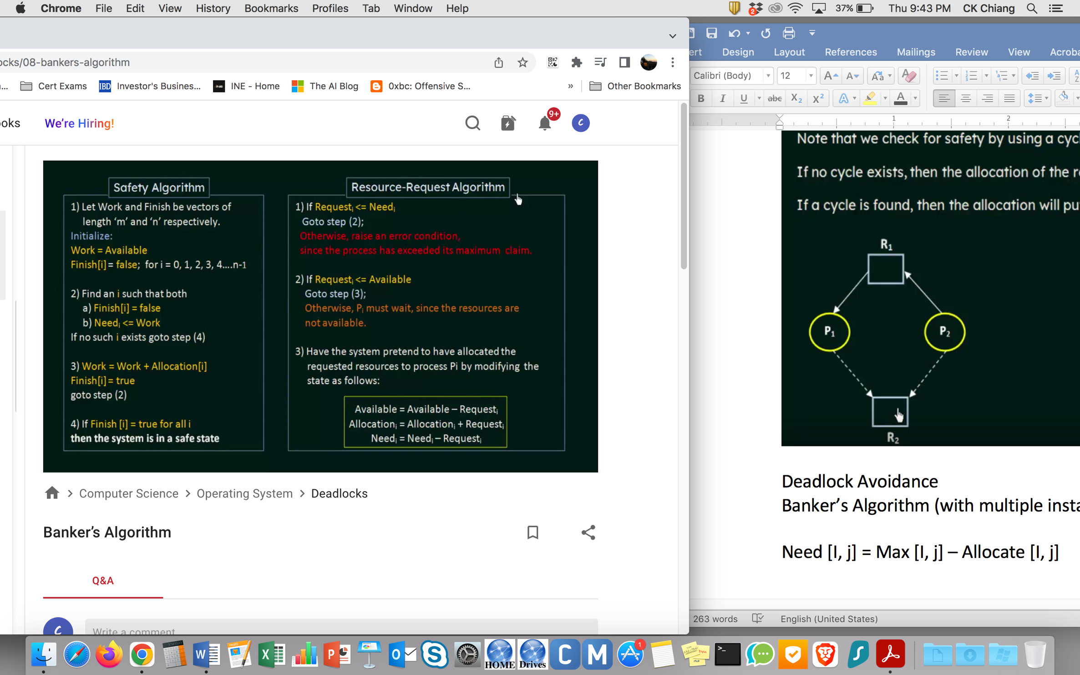

Safety Algorithm in Banker’s Algorithm

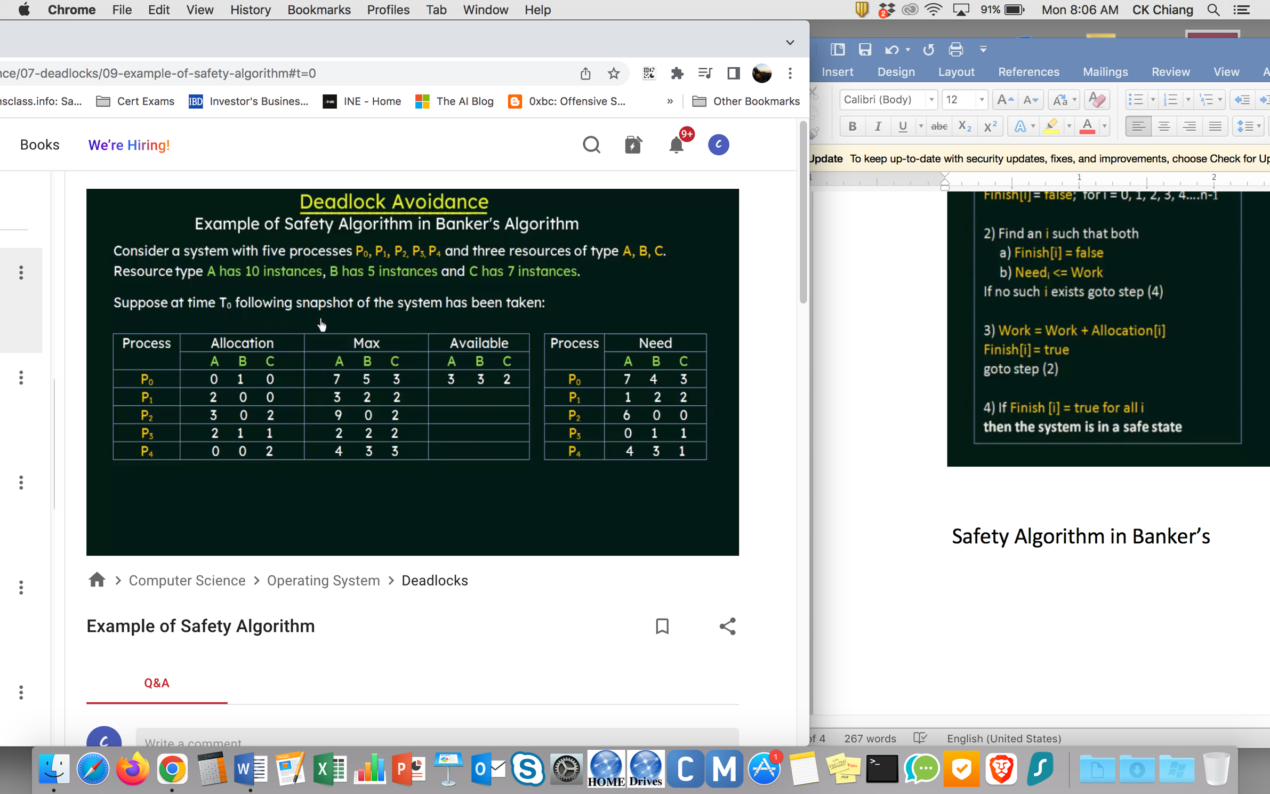

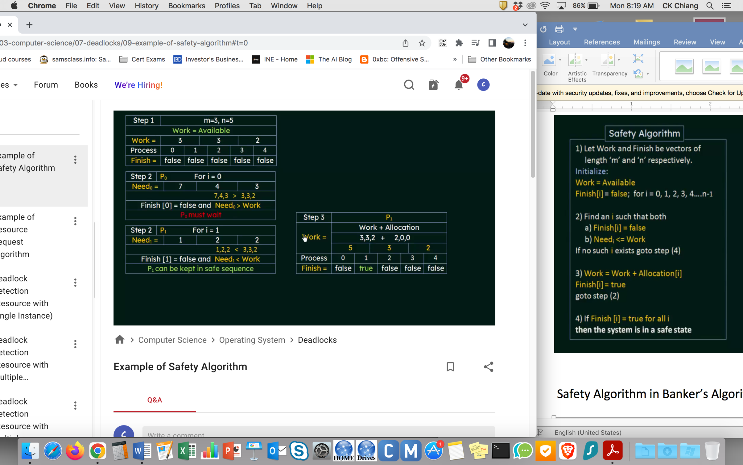

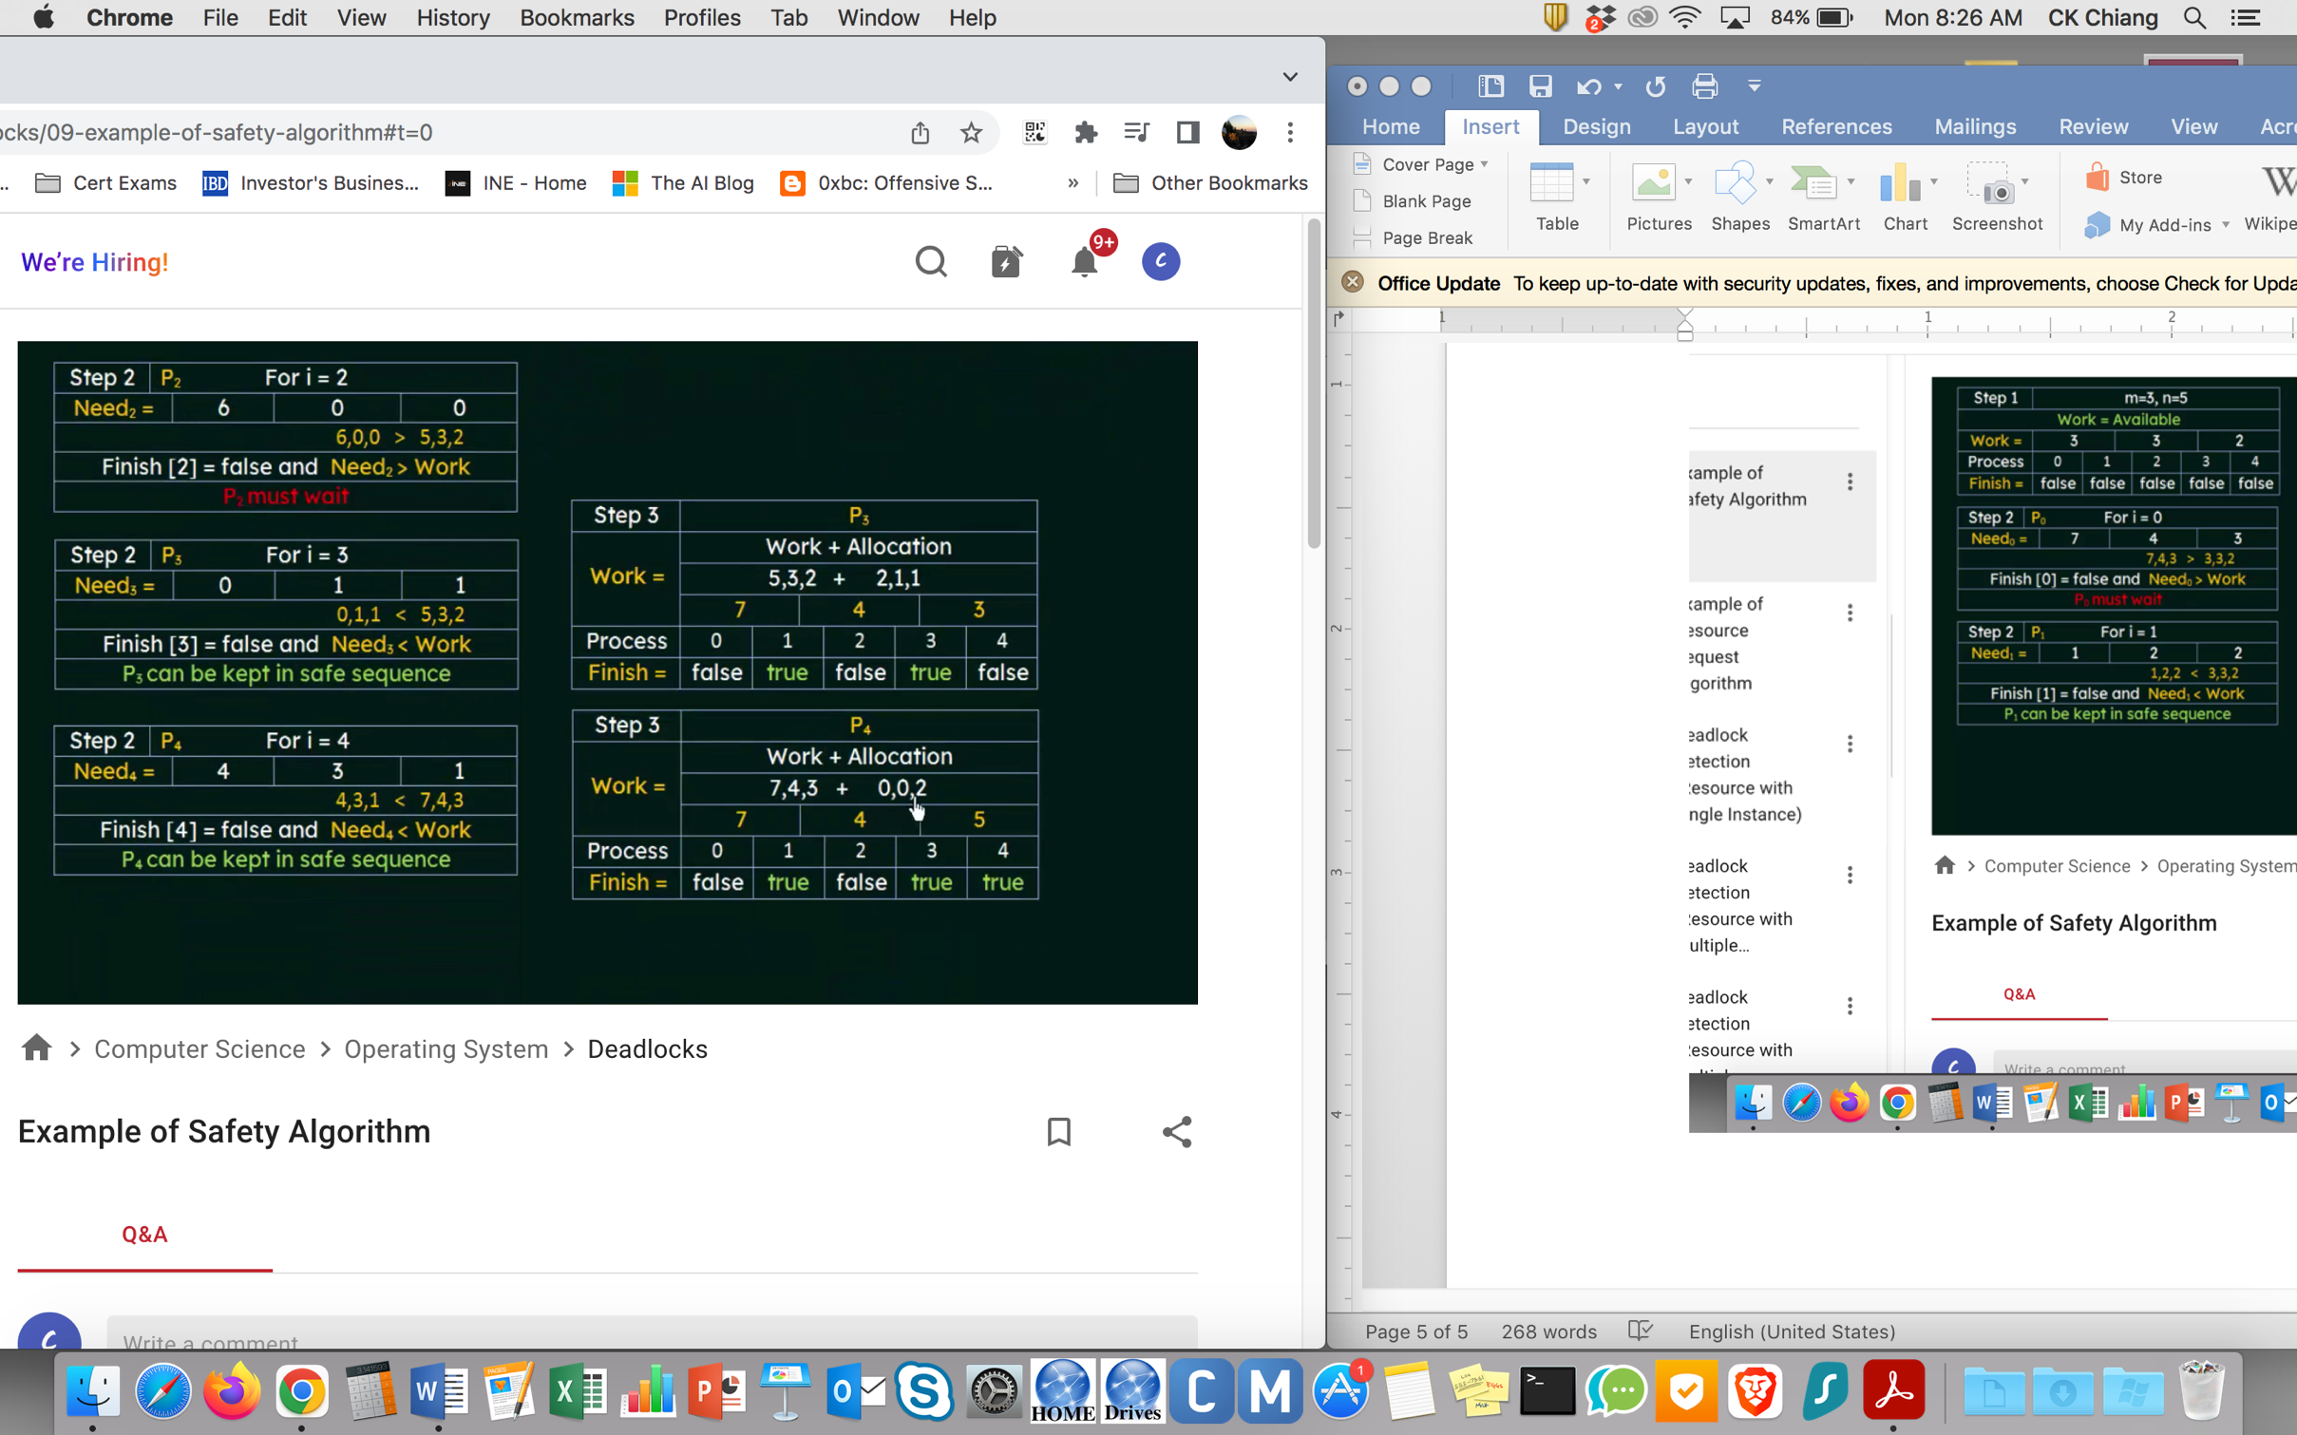

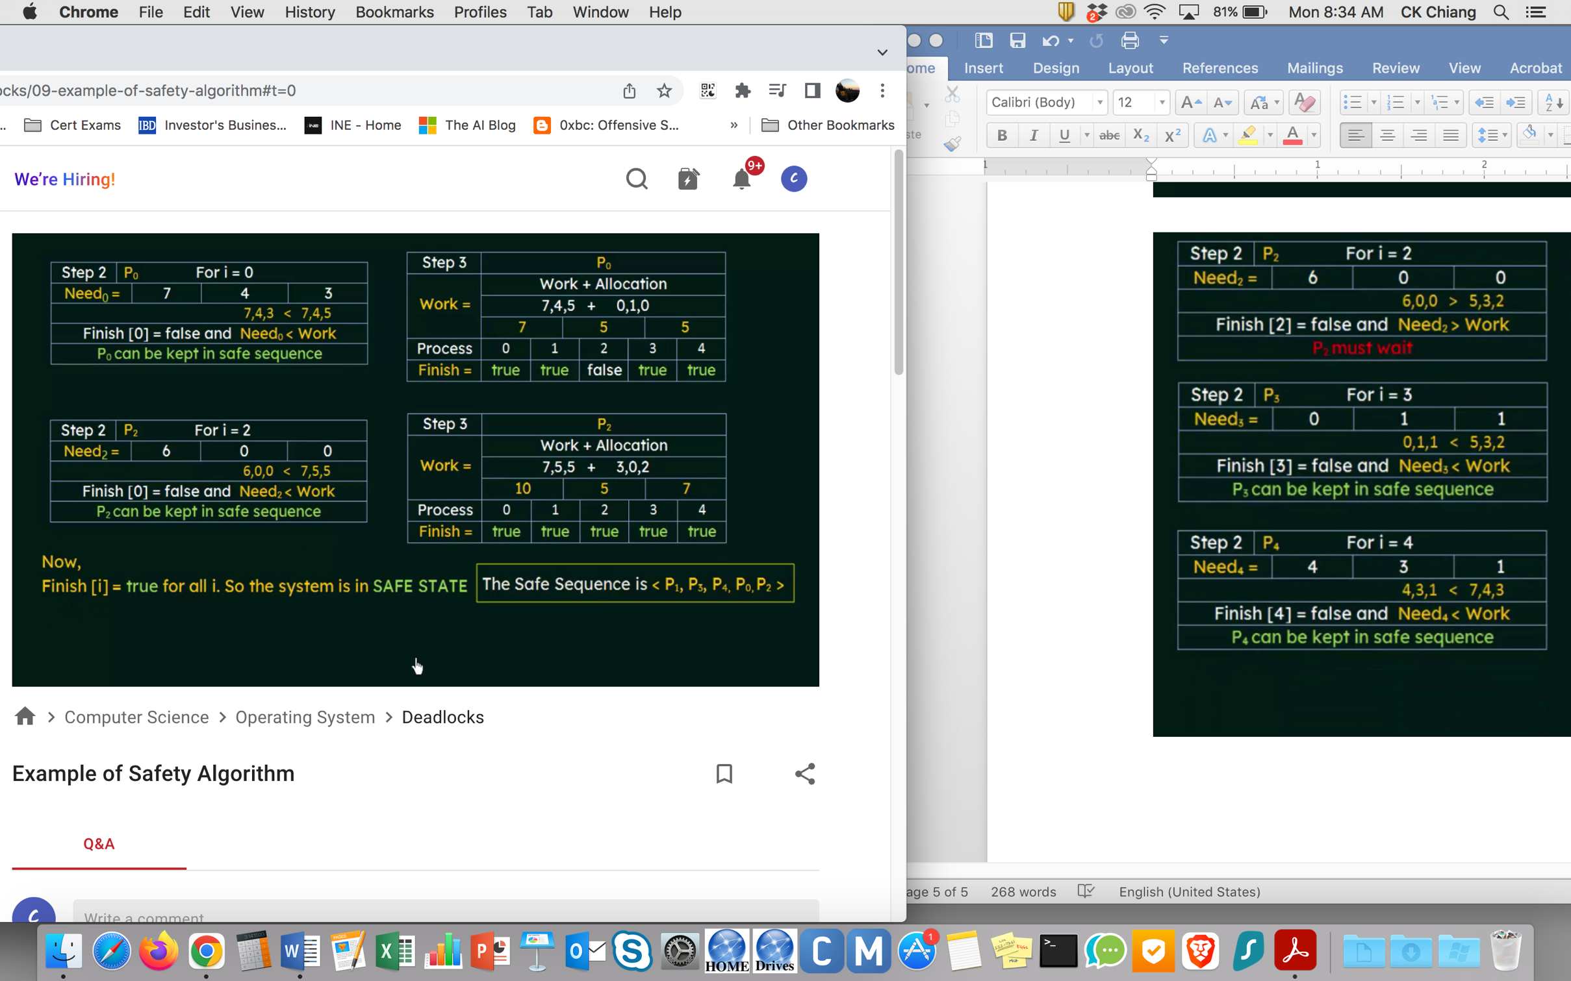

Resource-Request Algorithm in Banker’s Algorithm

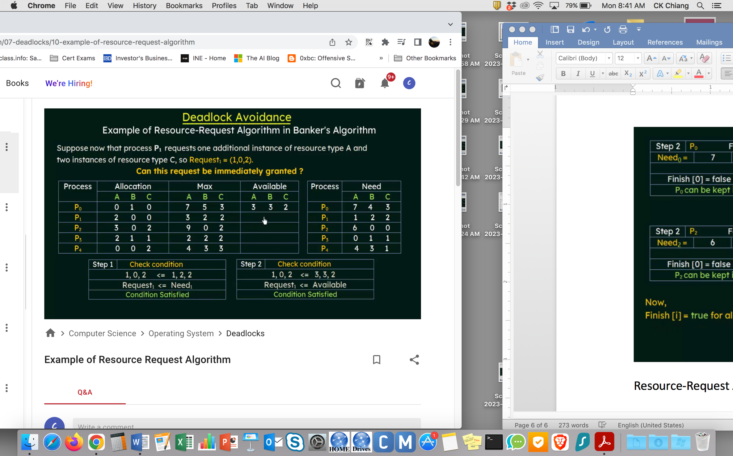

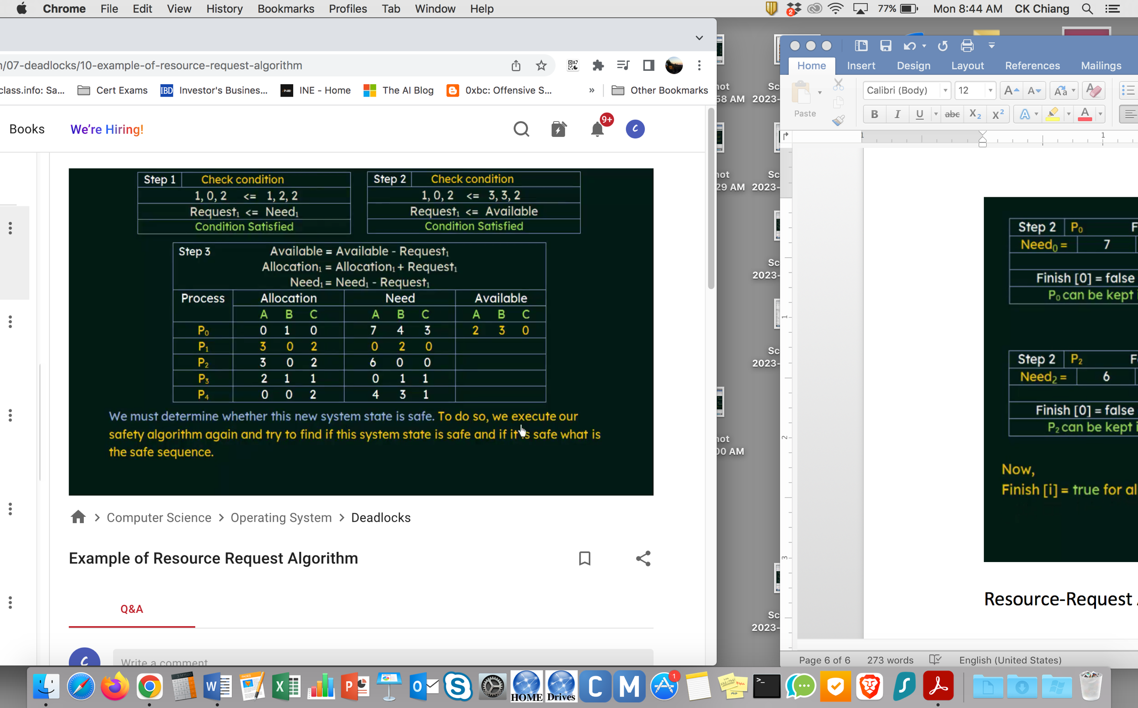

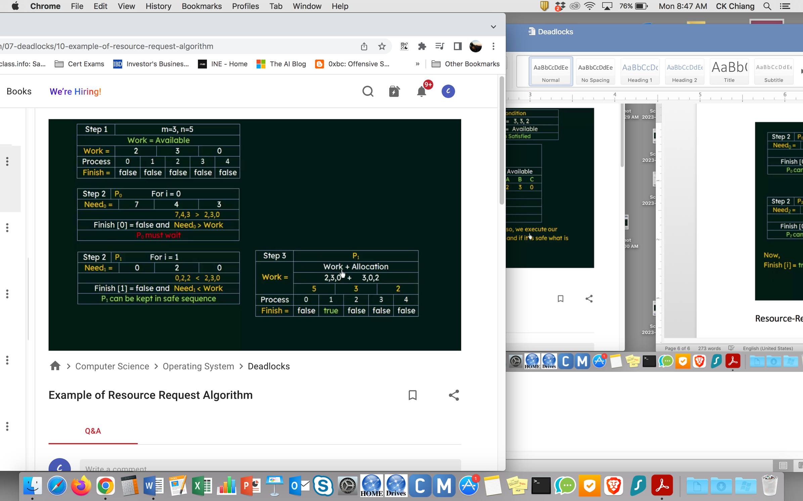

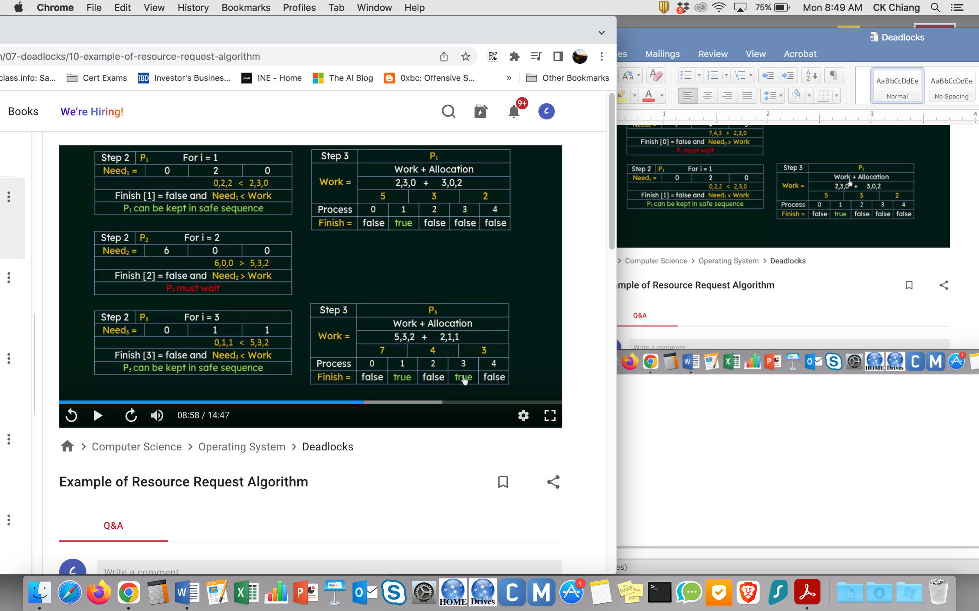

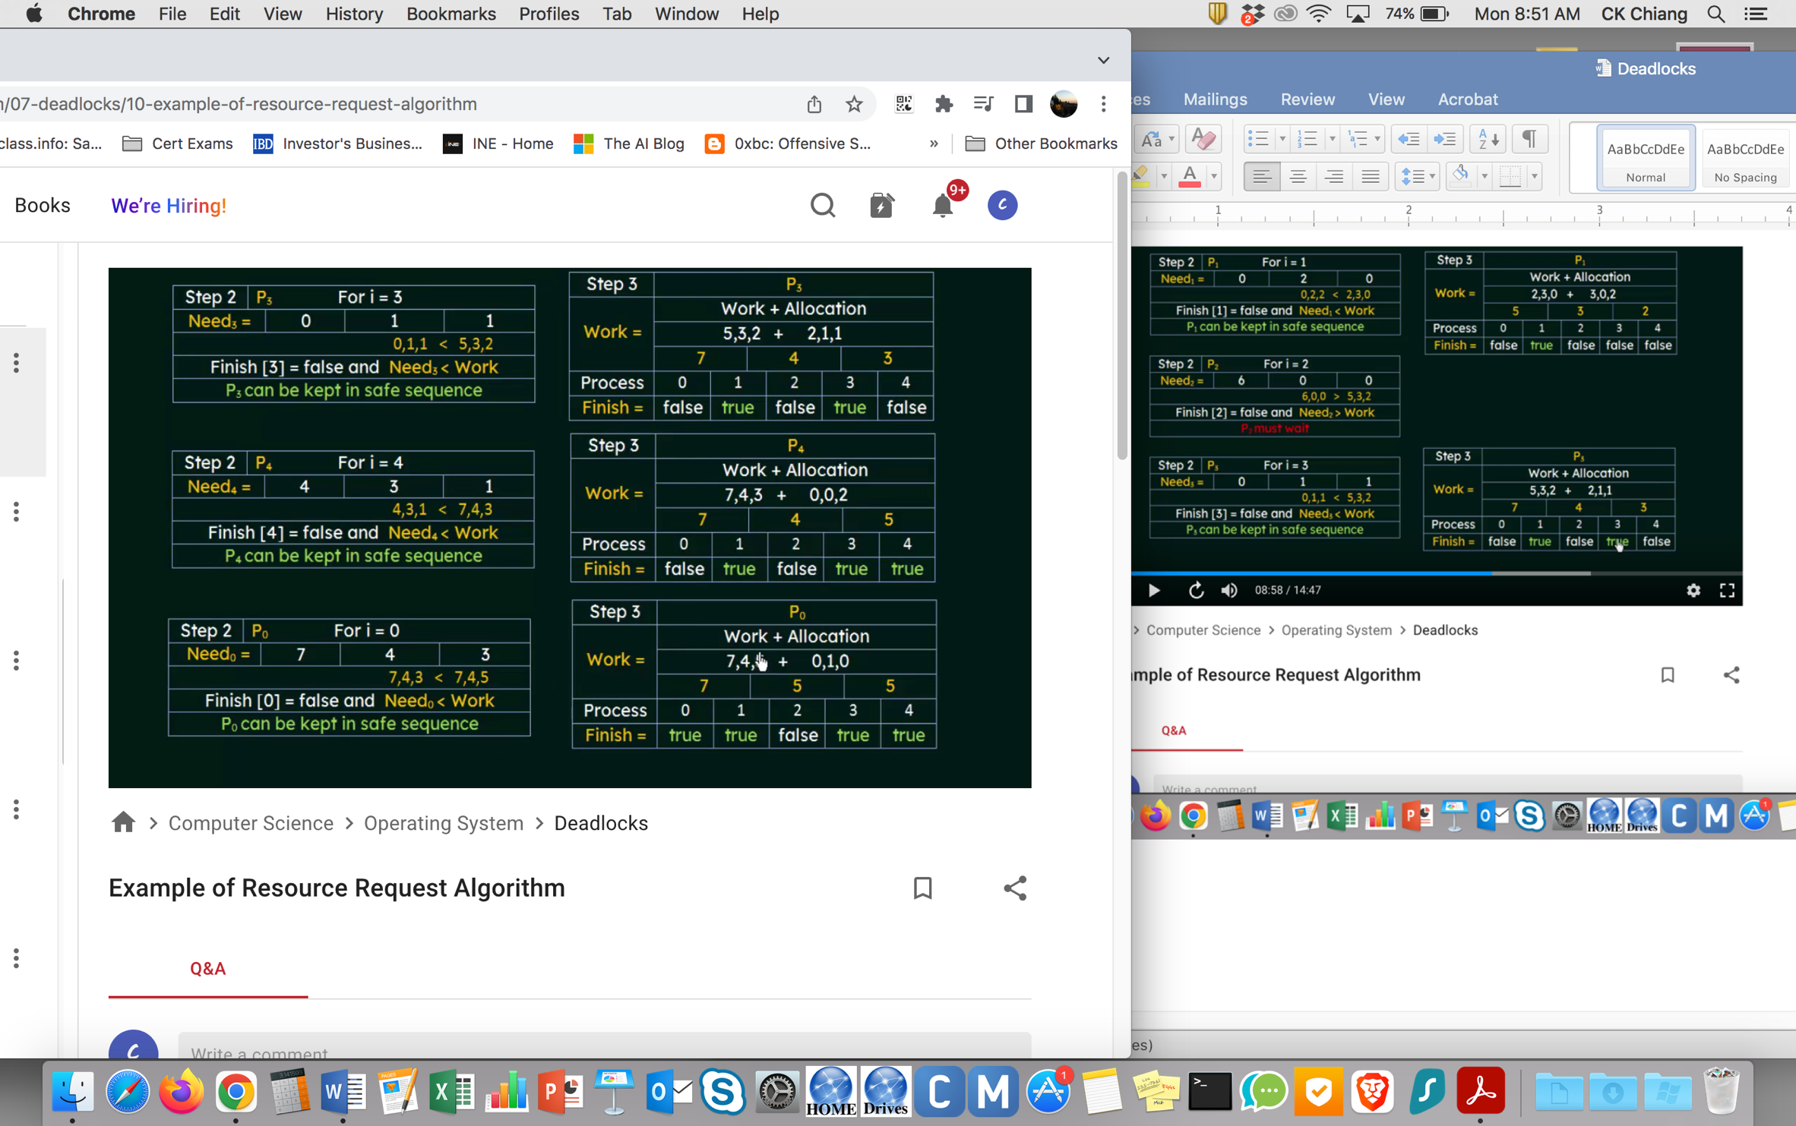

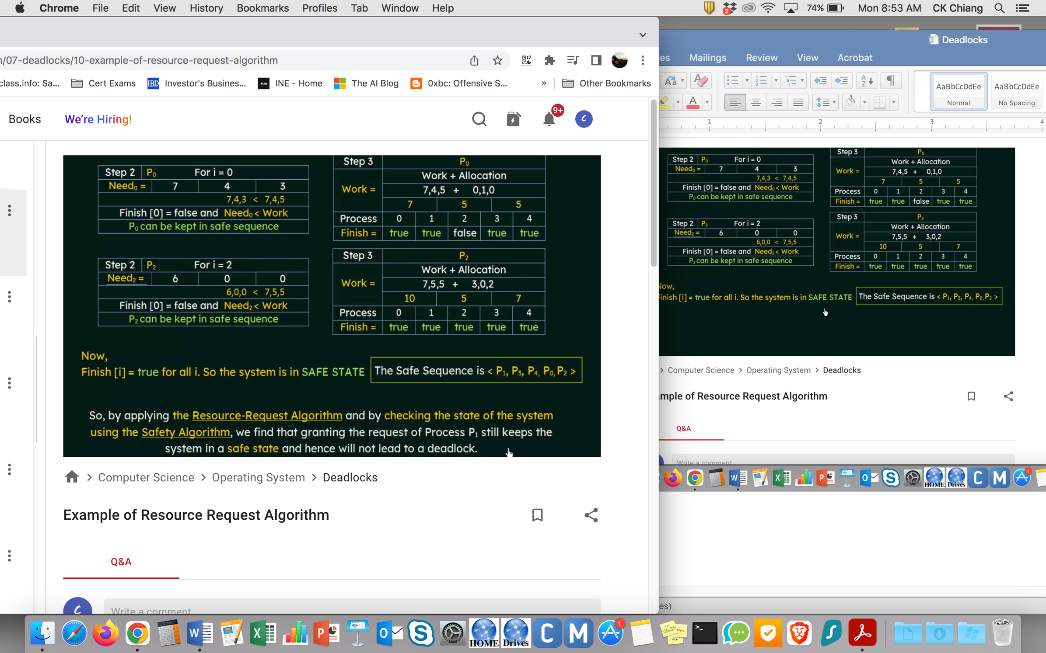

Deadlock Detection

Single Instance of Each Resource Type

Use Wait-For Graph

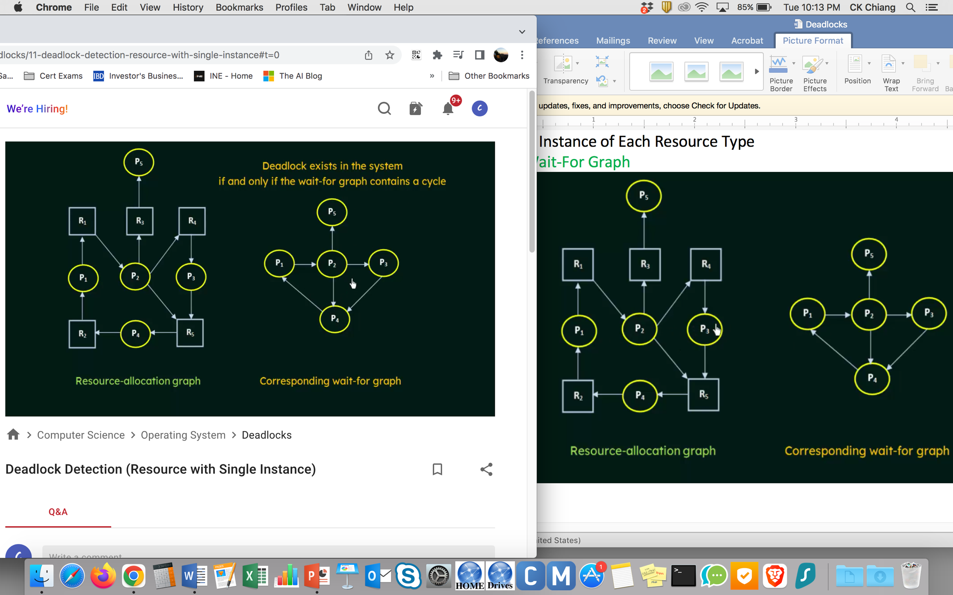

Multiple Instances of each Resources Type

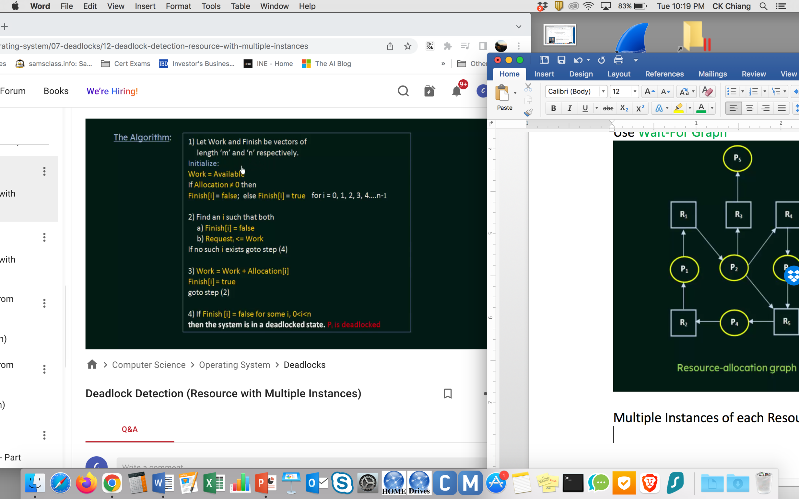

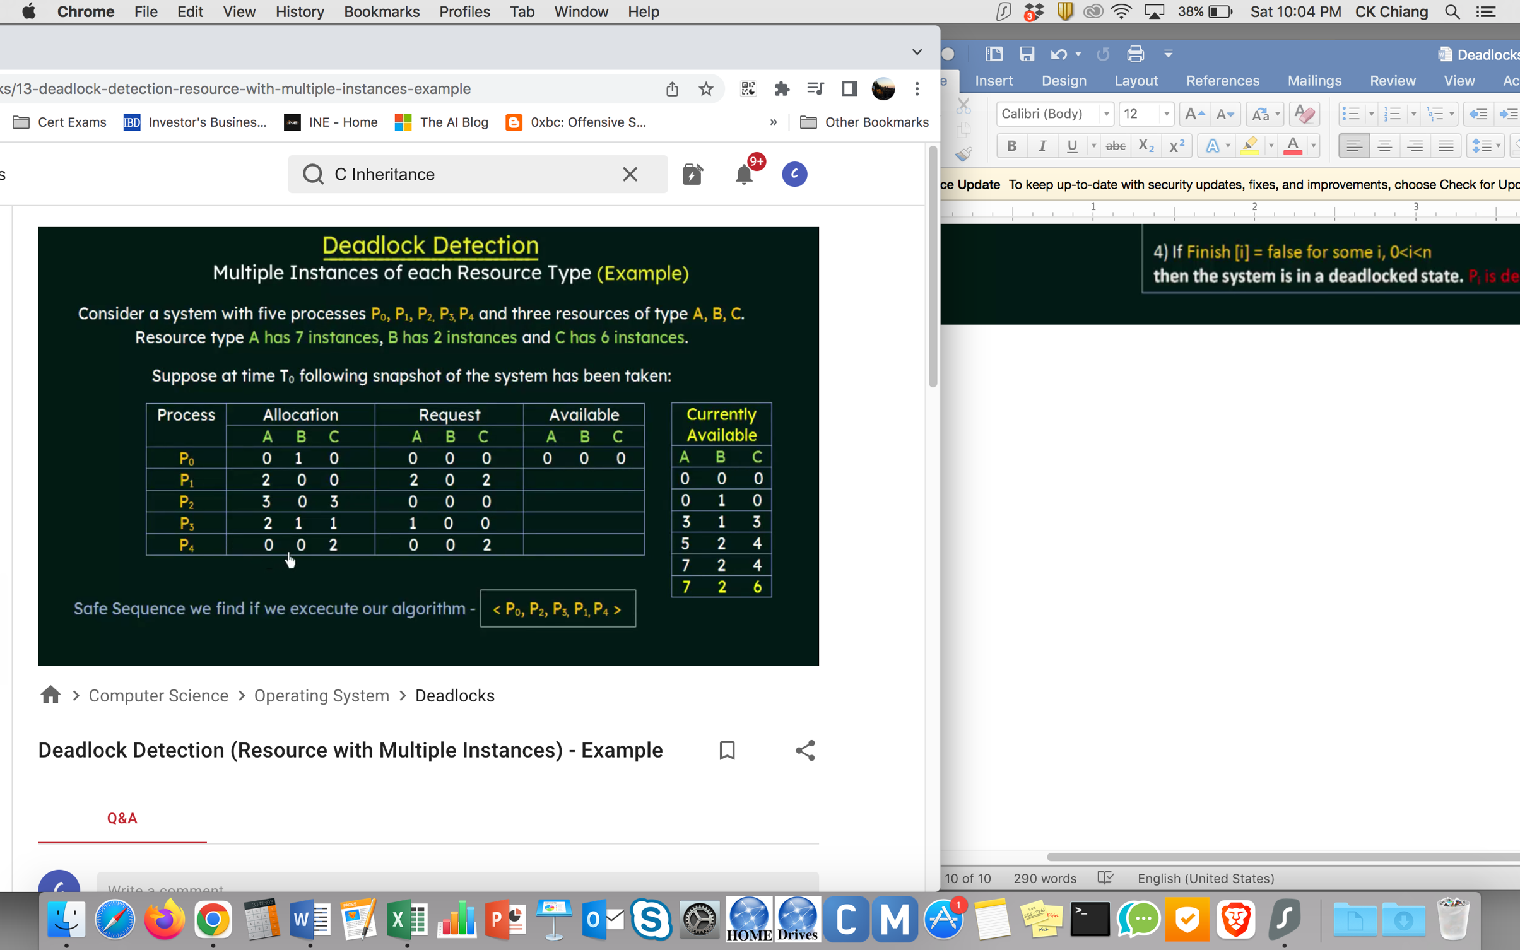

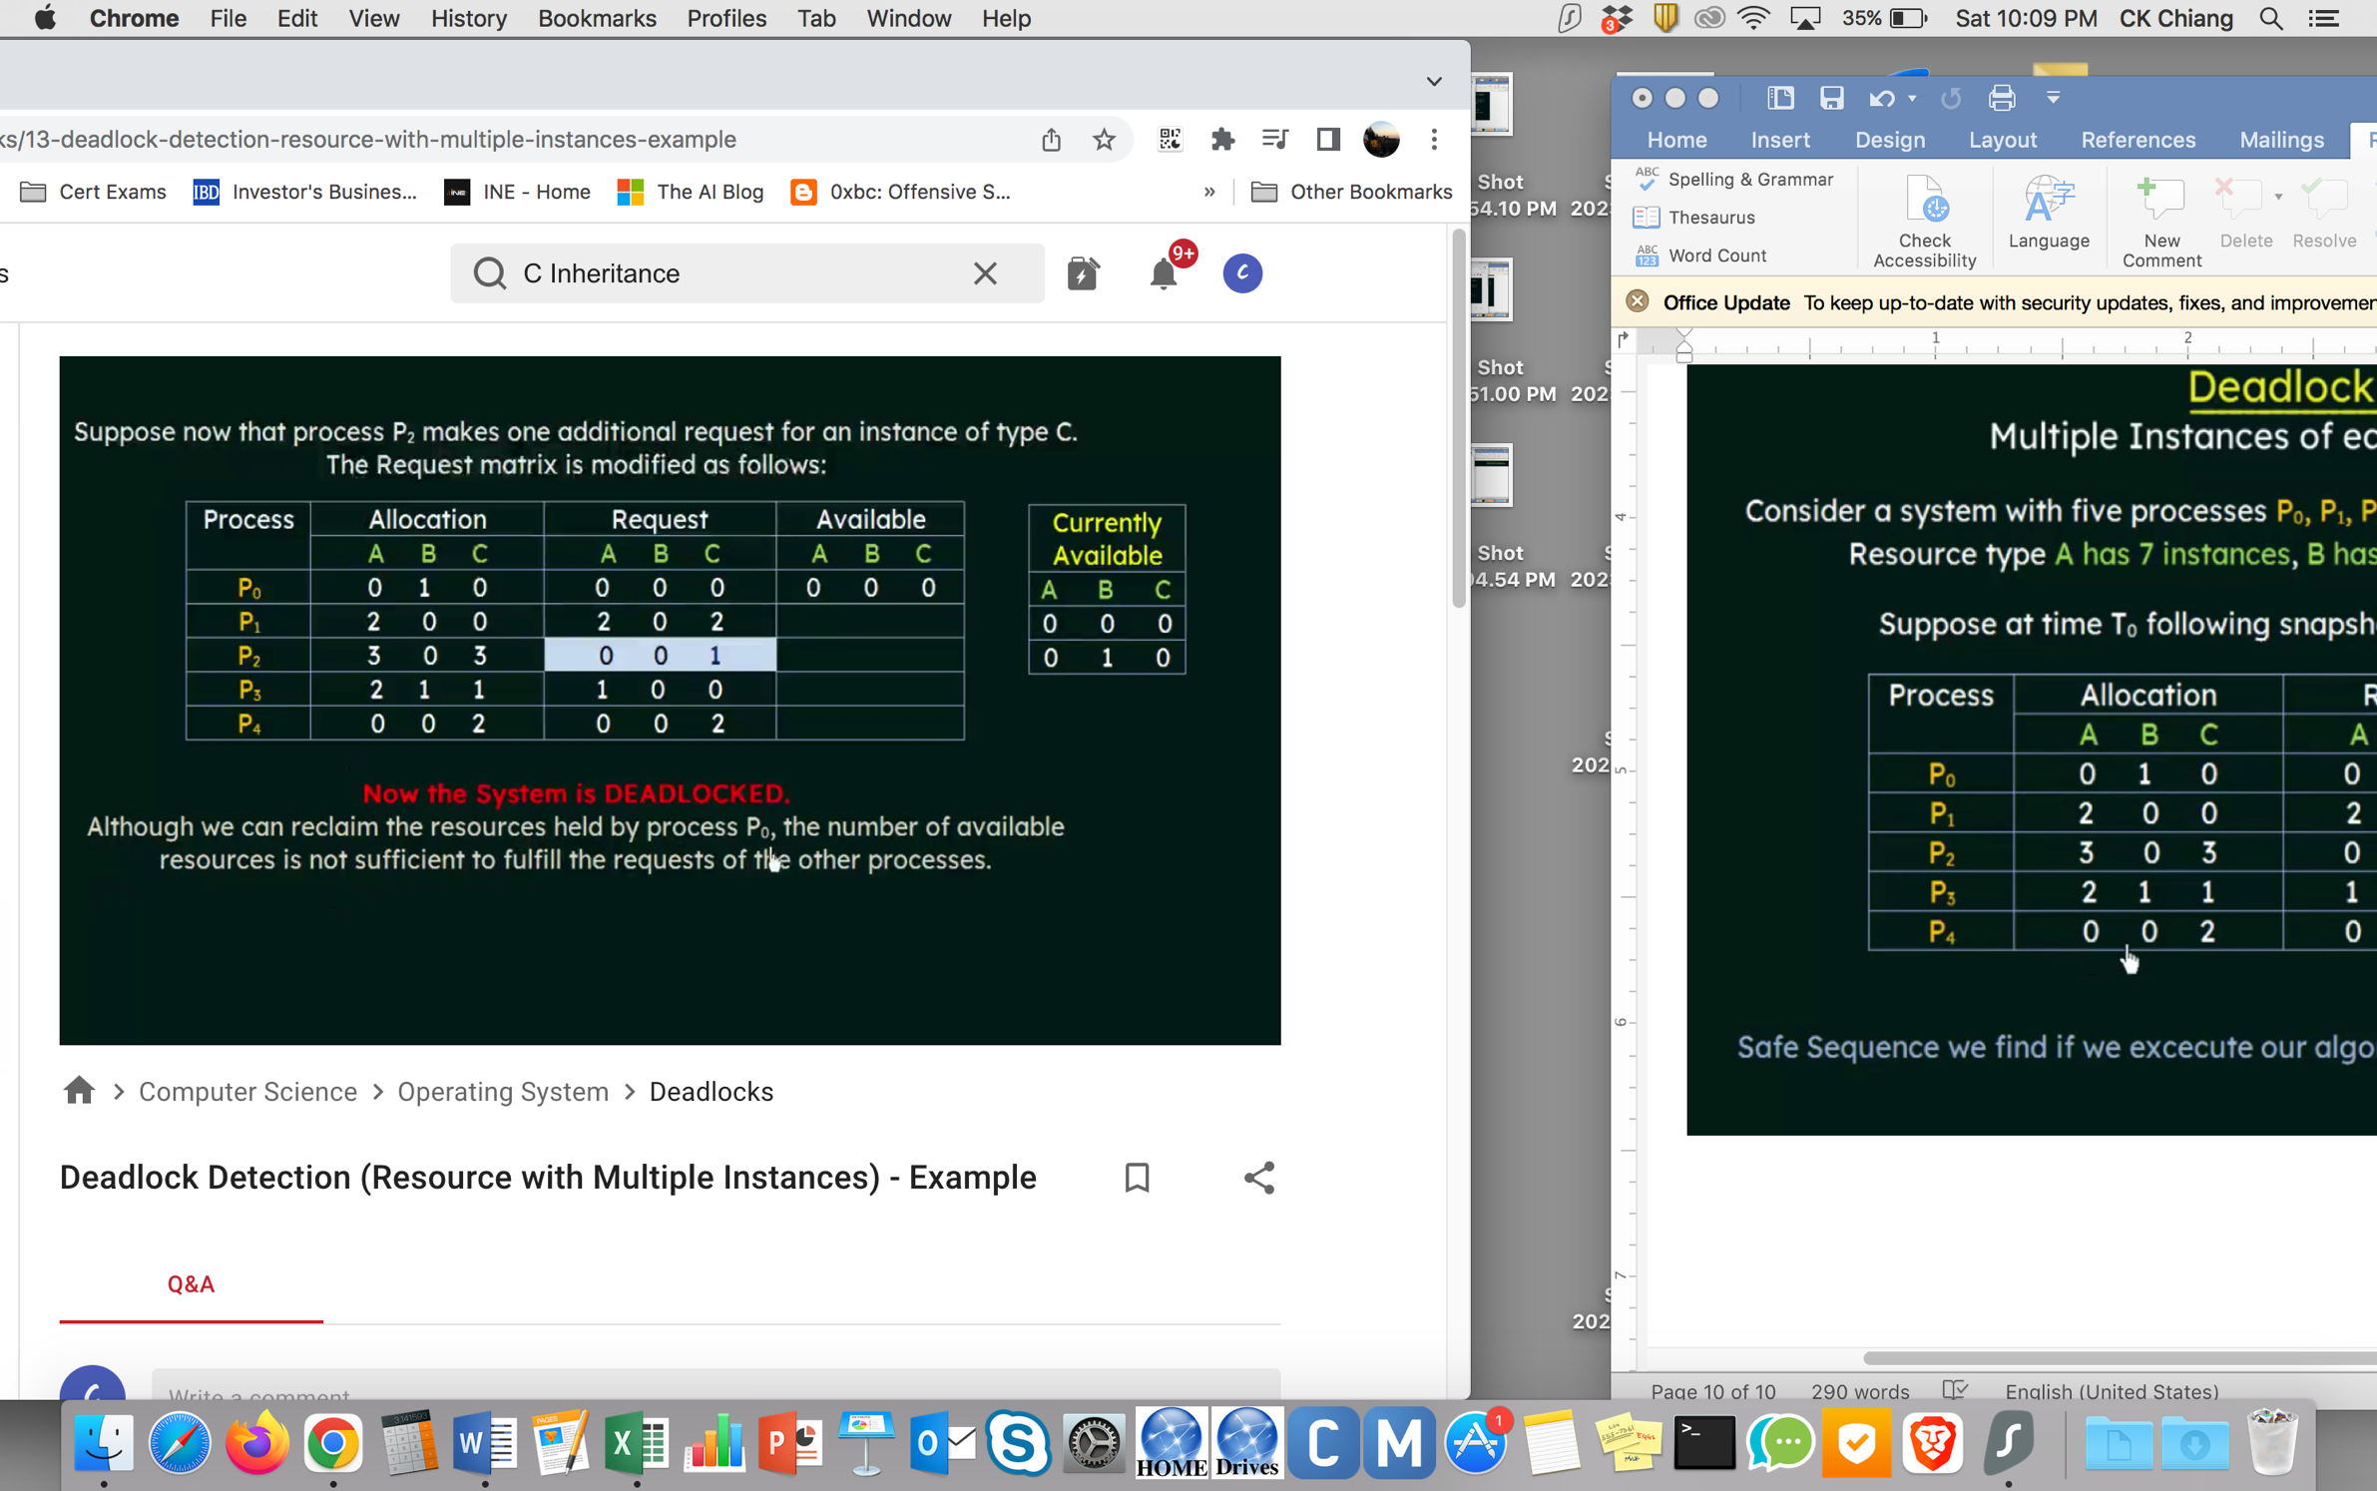

Recovery from Deadlock

Process Termination

* Deal with the deadlock manually
* Let the system recover from the deadlock automatically

How to break from the deadlock?

* Abort one or more processes to break the circular wait
* Preempt some resources from one ot more of the deadlocked processes

Process Termination

* Abort all deadlocked processes
* Abort one process at a time until the deadlock cycle is eliminated

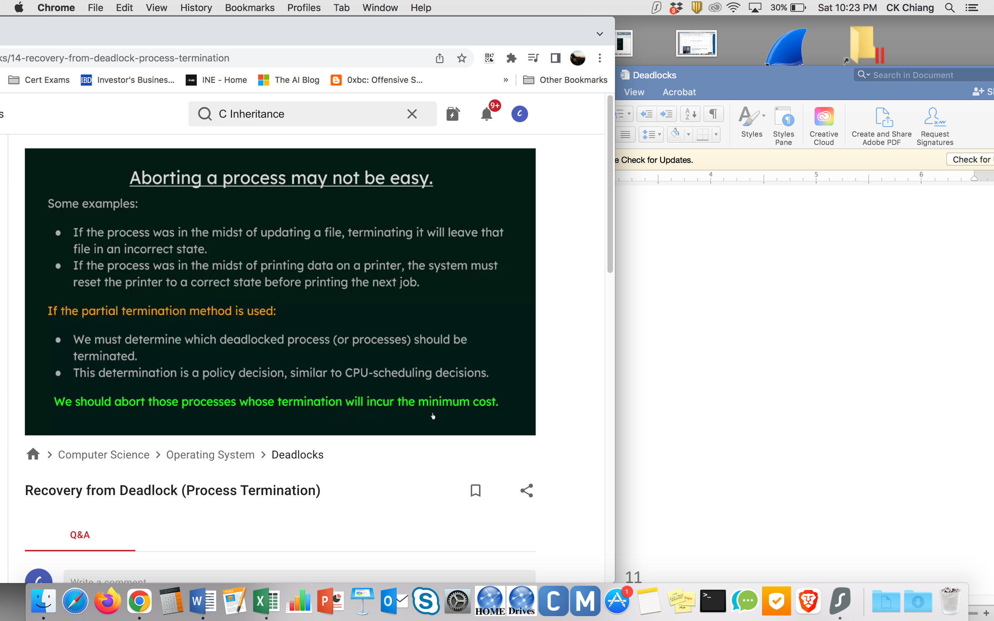

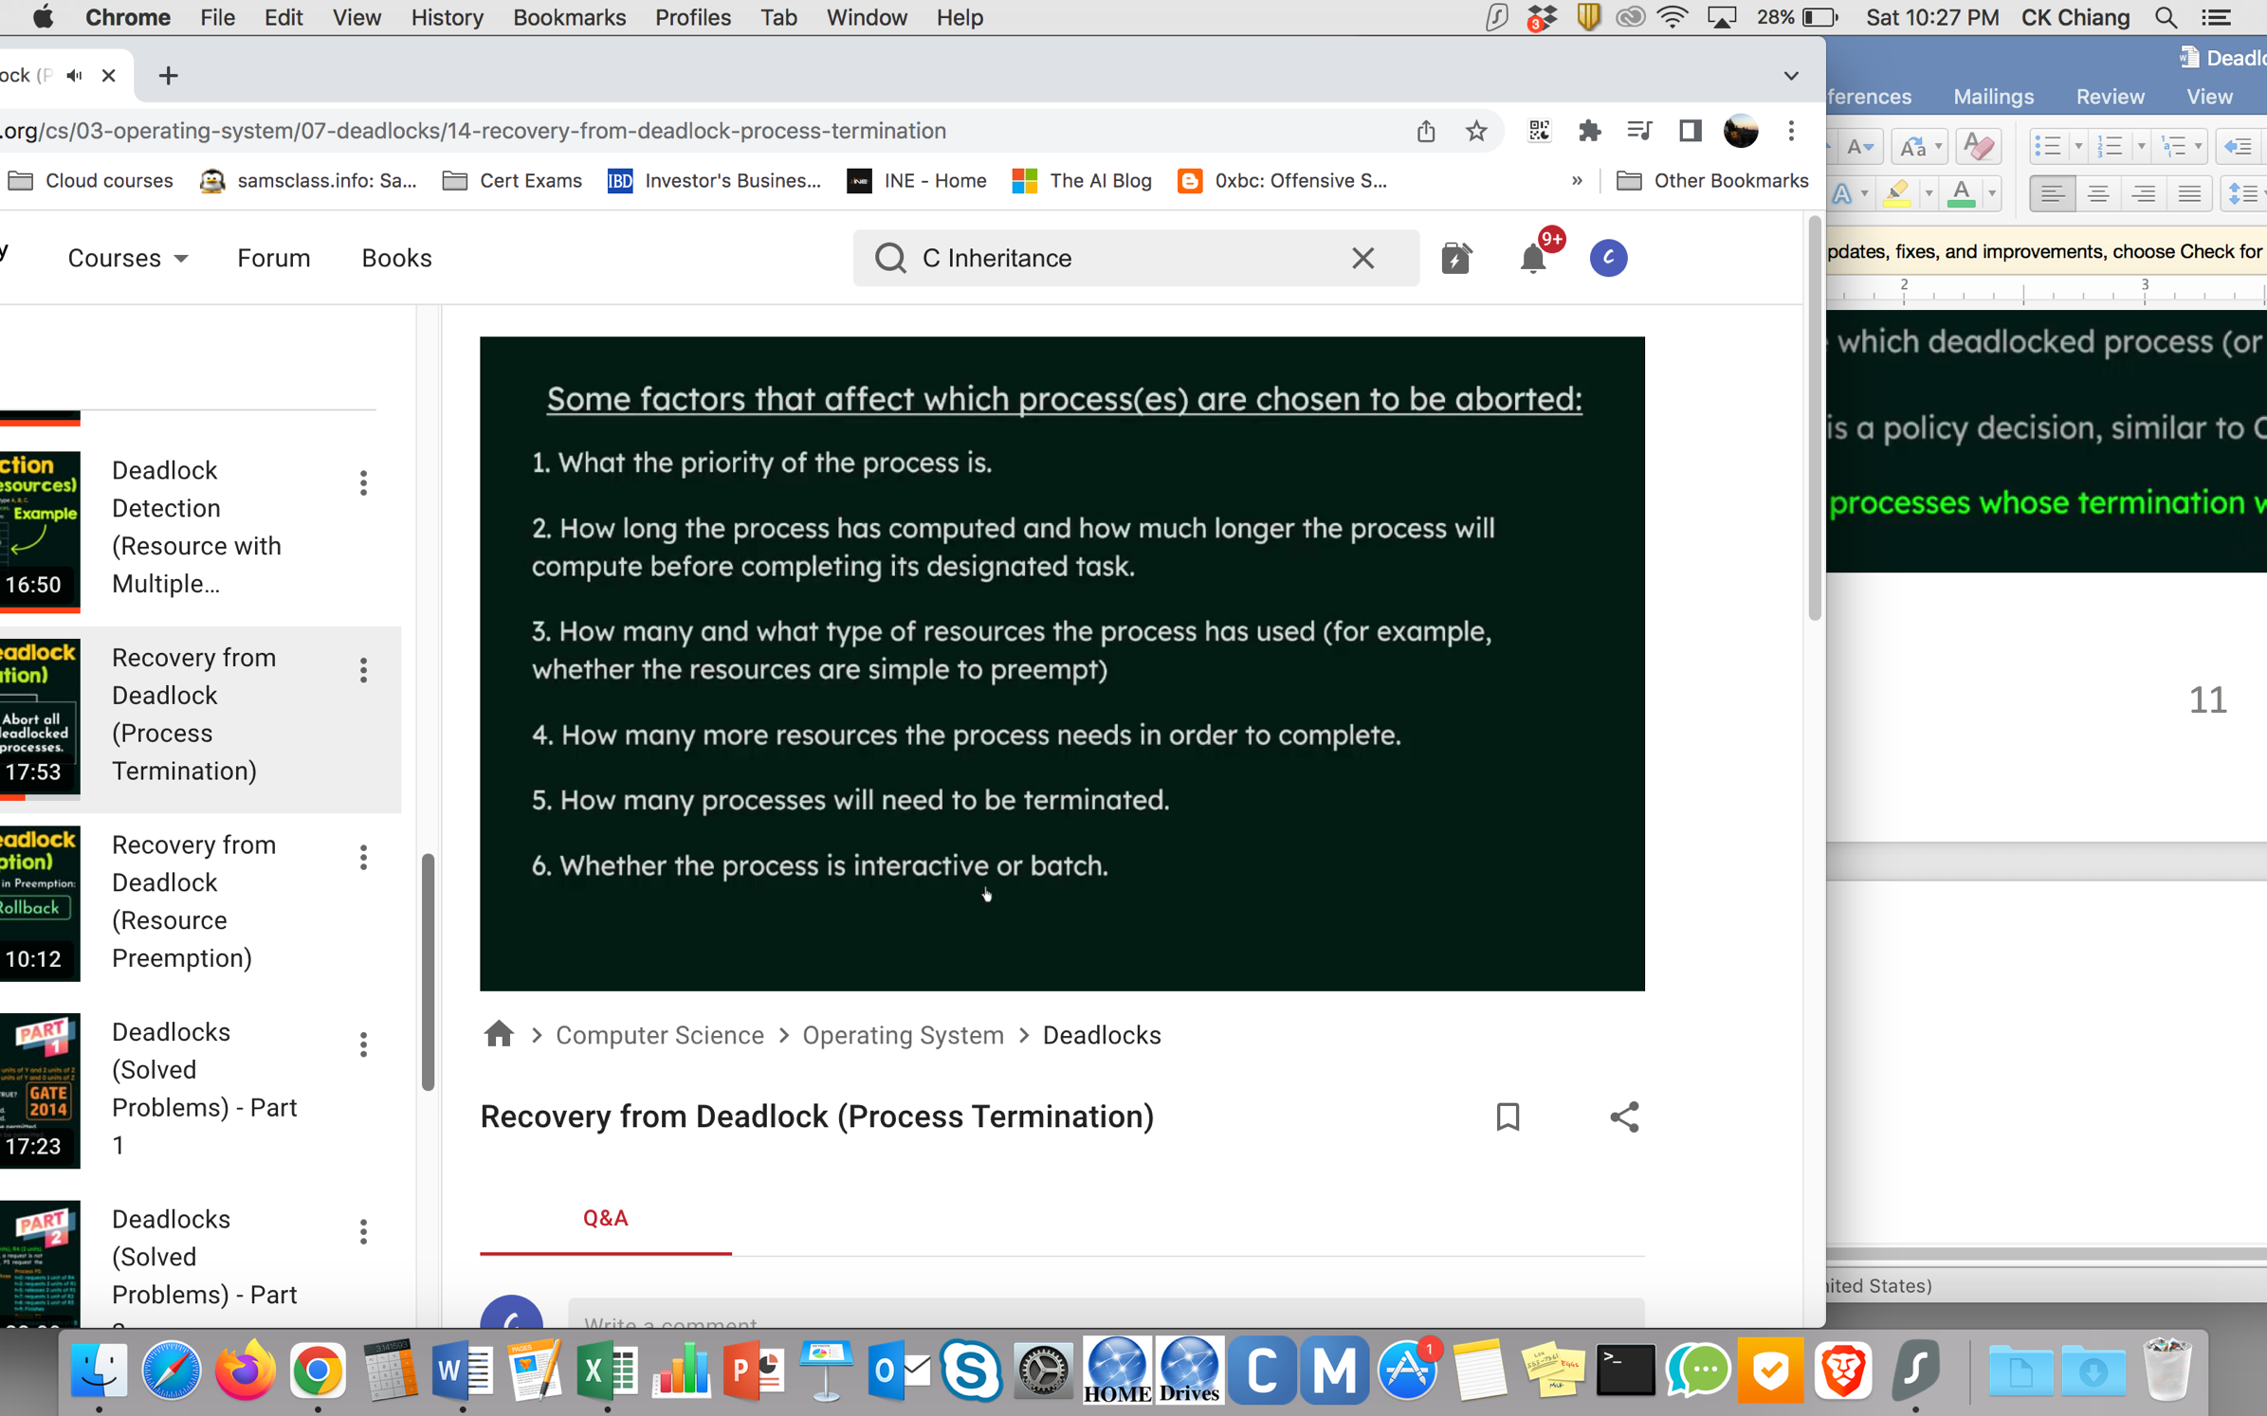

Recovery from Deadlock

Resource Preemption

* Selecting a victim (with min. cost)
* Rollback (abort the process and then restart it)
* Starvation